21.77: a) The field is all in the -direction (the rest cancels). From the 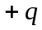 charges:
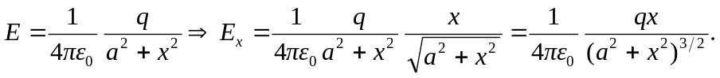
(Each contributes this). From the 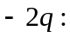
b) 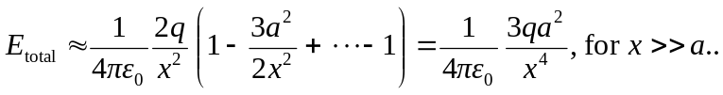
Note that a point charge drops off like 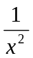 and a dipole like 

